Here’s my bar of music with staccato:
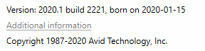
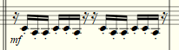
Here’s how it I assigned the staccato:
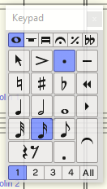
Here’s the configuration for staccato in the Playback Dictionary:
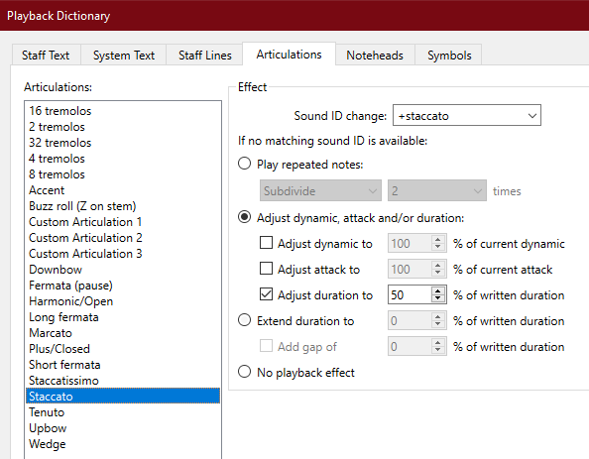

Matrix Cell B3 is selected for staccato when the MATRIX > Special Edition > 03 Orchestral Strings > 21S Strings violins is loaded and selected. Here’s what it looks like during Playback:
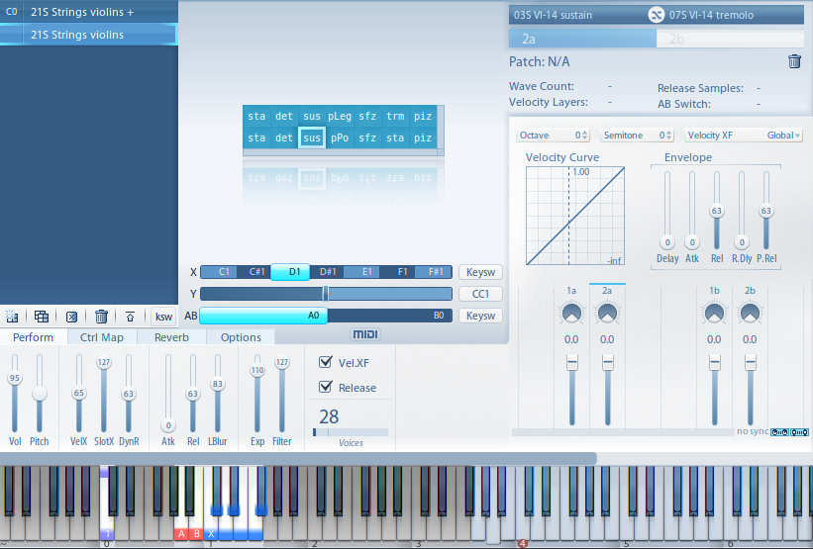
When PRESET > Sibelius > Special Edition 5.2 > SE+ Vol.1 > 03 Orchestral Strings > 21S Strings violins + is loaded, cell B9 is selected during playback.
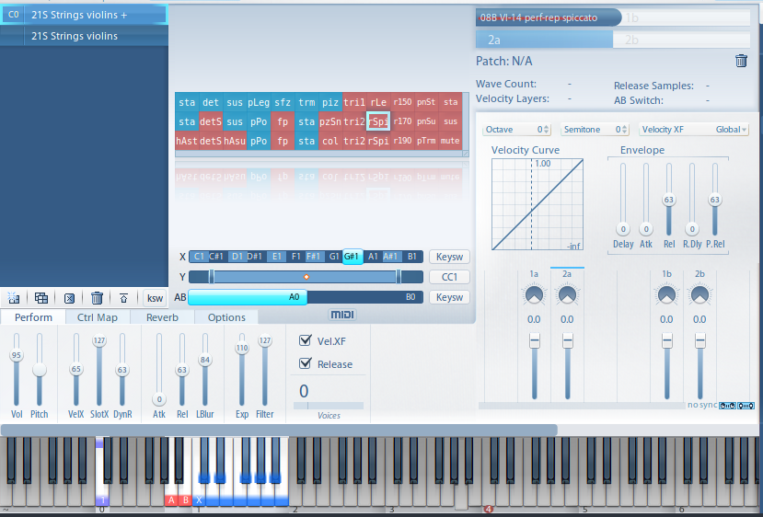
My Devices and SoundSets in Sibelius:
